Cointegration and ECM: EURUSD and GBPUSD
Method 27 / Engle-Granger on log closes / one-lag ECM / Alpari D1 full available history

Study setup
Logical pair: PX=EURUSD , PY=GBPUSD
Broker symbols: EURUSD_i , GBPUSD_i
Snapshot: 2026-11-03_majors_alpari_D1
Timeframe: D1
Matched window: 1999-01-05 to 2026-11-02 (UTC bar dates)
Matched level count n: 7202
Dropped unfinished last bar dated 2026-11-03 UTC after a tick-volume check against the prior complete day.
ECM lags of deltas: 1
Complete matched rows (Excel): EURUSD-GBPUSD_Coint_D1.xlsx
Complete matched rows (HTML table): EURUSD-GBPUSD_Coint_D1_data.html

Method carried forward
Engle-Granger cointegration works on log price levels, not returns. For each unordered pair, PX is the left leg and PY the right leg. Step one: OLS ln(PY) = alpha + beta * ln(PX) + e. Step two: statsmodels Engle-Granger coint test on (ln(PY), ln(PX)). Error-correction: delta ln(PY)_t = c + kappa * e_{t-1} + lagged delta ln(PY) and delta ln(PX) (one lag each) + u_t. Headline is the Engle-Granger p-value (lower = stronger evidence of a stationary spread) with kappa and beta reported alongside. Same-sample Pearson r of log returns is a side check only. beta is not an automatic lot-size hedge. This is not a trading signal.

Results (headline)
alpha: 0.310961
beta: 0.600813
Engle-Granger t: -1.401781
Engle-Granger p: 0.796902
5% critical value: -3.336979
ECM kappa: -0.000771
kappa t-stat: -1.3626
ECM R^2: 0.000672
spread std: 0.117572
Pearson r (returns): 0.641738

Conclusion
Engle-Granger for PY=GBPUSD on PX=EURUSD: beta=0.6008, alpha=0.3110, coint_t=-1.4018, p=0.7969 (5% crit=-3.3370). ECM kappa=-0.0008 (t=-1.36). Pearson r of returns = 0.6417. beta is not a lot-size hedge. Not a trading signal.

Charts
Daily closes

Engle-Granger residual spread
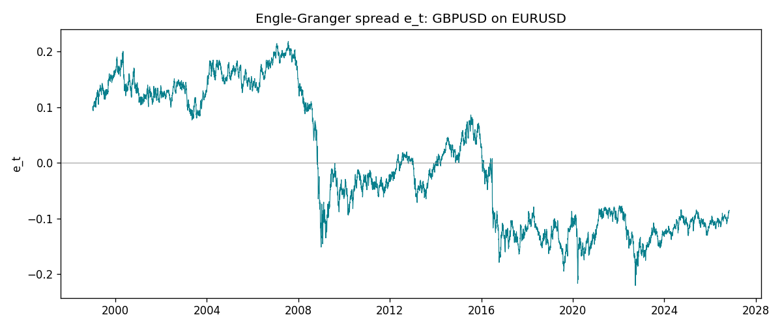
Daily log returns
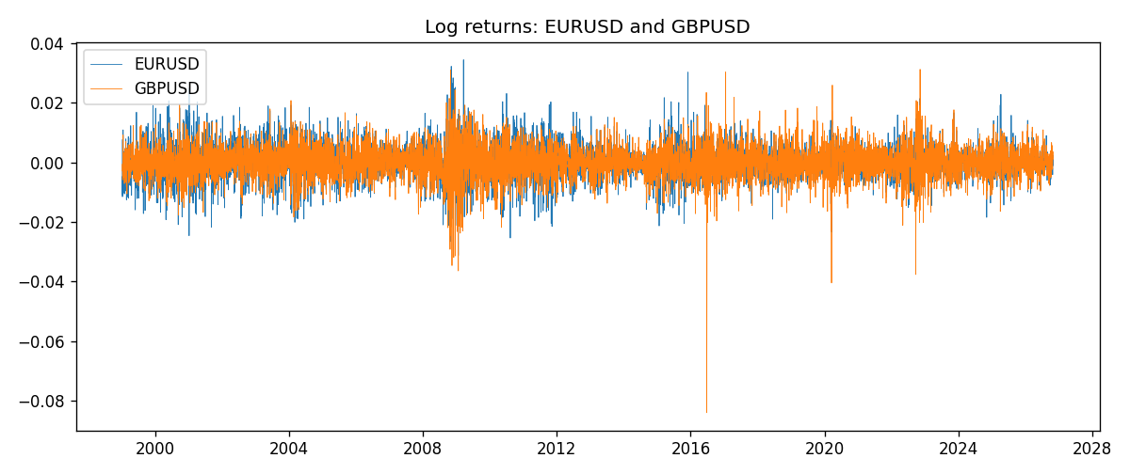

Data report
Matched rows are in the sibling Excel workbook named EURUSD-GBPUSD_Coint_D1.xlsx. Embedding all rows as a Word table is impractical; this file holds column summaries and the first and last 15 matched rows.
Column summaries
column | count | mean | std | min | 25% | 50% | 75% | max
EURUSD_open | 7202 | 1.1812936 | 0.15087968 | 0.8272 | 1.086065 | 1.166145 | 1.293925 | 1.5995
GBPUSD_open | 7202 | 1.5160822 | 0.2182507 | 1.06854 | 1.325005 | 1.51141 | 1.63166 | 2.1066
EURUSD_high | 7202 | 1.1864255 | 0.15147858 | 0.8326 | 1.0901775 | 1.17127 | 1.2992275 | 1.6038
GBPUSD_high | 7202 | 1.5223773 | 0.21881719 | 1.08366 | 1.329795 | 1.51815 | 1.63839 | 2.1161
EURUSD_low | 7202 | 1.1762813 | 0.15020267 | 0.8227 | 1.0819975 | 1.162535 | 1.288315 | 1.5865
GBPUSD_low | 7202 | 1.5097565 | 0.21747799 | 1.03518 | 1.3195075 | 1.503295 | 1.6243825 | 2.0983
EURUSD_close | 7202 | 1.1813323 | 0.15085599 | 0.8267 | 1.0860025 | 1.166105 | 1.2939475 | 1.5997
GBPUSD_close | 7202 | 1.5161468 | 0.21820921 | 1.06879 | 1.325125 | 1.511325 | 1.632095 | 2.1065
EURUSD_tick_volume | 7202 | 102990.53 | 173401.83 | 218 | 9388.25 | 52708 | 99433.75 | 1471626
GBPUSD_tick_volume | 7202 | 94813.509 | 153540.37 | 62 | 9988.5 | 52886.5 | 91789.25 | 1273370
EURUSD_spread | 7202 | 19.400444 | 16.577153 | 0 | 8 | 12 | 30 | 50
GBPUSD_spread | 7202 | 26.974313 | 19.194125 | 0 | 11 | 20 | 50 | 50
EURUSD_real_volume | 7202 | 4.0233049e+10 | 1.6674277e+11 | 0 | 0 | 0 | 0 | 3.6149665e+12
GBPUSD_real_volume | 7202 | 3.5555961e+09 | 8.4432361e+10 | 0 | 0 | 0 | 0 | 2.4038164e+12
EURUSD_log_price | 7202 | 0.15839116 | 0.12909616 | -0.19031341 | 0.08250352 | 0.15366913 | 0.25769762 | 0.46981611
GBPUSD_log_price | 7202 | 0.40612474 | 0.14085115 | 0.06652717 | 0.28150679 | 0.41298675 | 0.48986447 | 0.7450278
EURUSD_log_return | 7202 | -7.71e-06 | 0.00580133 | -0.03123819 | -0.00324586 | 0 | 0.00325471 | 0.03433183
GBPUSD_log_return | 7202 | -2.587e-05 | 0.00564523 | -0.08388241 | -0.00313091 | 3.124e-05 | 0.00317757 | 0.03112653
spread_e | 7202 | -0 | 0.11757162 | -0.22040198 | -0.10892622 | -0.02452624 | 0.12454252 | 0.21853652
ecm_fitted | 7201 | -2.547e-05 | 0.00014634 | -0.00185339 | -0.00012342 | -2.081e-05 | 7.144e-05 | 0.00073164
First 15 matched rows (selected columns)
time | EURUSD_log_price | GBPUSD_log_price | spread_e | EURUSD_log_return | GBPUSD_log_return
1999-01-05 | 0.16194877 | 0.50361972 | 0.095357527 | -0.0048360507 | -0.0028966287
1999-01-06 | 0.1504008 | 0.5030152 | 0.10169117 | -0.011547966 | -0.00060452184
1999-01-07 | 0.15802886 | 0.50089649 | 0.094989423 | 0.0076280636 | -0.002118709
1999-01-08 | 0.14712606 | 0.49500107 | 0.095644545 | -0.010902799 | -0.0058954193
1999-01-11 | 0.14002278 | 0.48931594 | 0.094227157 | -0.007103287 | -0.0056851331
1999-01-12 | 0.14453315 | 0.49158164 | 0.093782968 | 0.0045103728 | 0.0022657001
1999-01-13 | 0.1553785 | 0.50071468 | 0.096399985 | 0.010845346 | 0.0091330396
1999-01-14 | 0.1553785 | 0.50265231 | 0.098337618 | 0 | 0.0019376331
1999-01-15 | 0.14522525 | 0.50089649 | 0.102682 | -0.010153245 | -0.0017558204
1999-01-18 | 0.14885095 | 0.50210773 | 0.10171487 | 0.0036256946 | 0.0012112405
1999-01-19 | 0.14867859 | 0.50398226 | 0.10369295 | -0.00017235436 | 0.0018745281
1999-01-20 | 0.14548467 | 0.49907688 | 0.10070652 | -0.0031939256 | -0.0049053846
1999-01-21 | 0.14850621 | 0.50222878 | 0.10204304 | 0.0030215416 | 0.0031518998
1999-01-22 | 0.14729869 | 0.50470694 | 0.1052467 | -0.0012075213 | 0.0024781662
1999-01-25 | 0.14427349 | 0.50591358 | 0.10827091 | -0.0030251979 | 0.0012066366
Last 15 matched rows (selected columns)
time | EURUSD_log_price | GBPUSD_log_price | spread_e | EURUSD_log_return | GBPUSD_log_return
2026-10-13 | 0.11301614 | 0.28166903 | -0.097193818 | 0.0037402957 | 0.0036434319
2026-10-14 | 0.10925791 | 0.27675256 | -0.099852296 | -0.0037582255 | -0.0049164679
2026-10-15 | 0.11486322 | 0.2833502 | -0.096622397 | 0.0056053107 | 0.0065976411
2026-10-16 | 0.11663571 | 0.28710941 | -0.093928126 | 0.0017724895 | 0.0037592051
2026-10-19 | 0.11409625 | 0.28535938 | -0.094152415 | -0.0025394633 | -0.0017500314
2026-10-20 | 0.11648442 | 0.29095172 | -0.089994913 | 0.0023881672 | 0.0055923442
2026-10-21 | 0.11616395 | 0.29219935 | -0.088554739 | -0.00032046717 | 0.0012476328
2026-10-22 | 0.11456899 | 0.29242331 | -0.087372505 | -0.0015949606 | 0.00022396082
2026-10-23 | 0.11323047 | 0.29030862 | -0.088683 | -0.001338521 | -0.0021146949
2026-10-26 | 0.11095981 | 0.28787455 | -0.089752827 | -0.0022706559 | -0.0024340661
2026-10-27 | 0.10680747 | 0.28550971 | -0.089622886 | -0.004152342 | -0.0023648393
2026-10-28 | 0.10903376 | 0.2870869 | -0.089383291 | 0.0022262927 | 0.0015771808
2026-10-29 | 0.1112909 | 0.29067509 | -0.087151213 | 0.0022571351 | 0.0035881935
2026-10-30 | 0.11014505 | 0.29202015 | -0.085117714 | -0.0011458446 | 0.0013450605
2026-11-02 | 0.11226562 | 0.29311727 | -0.085294653 | 0.002120569 | 0.0010971256

